**SECTION 1**

Q1. (C).

select * from (select a.emp_id, a.emp_name, a.salary, b.dept_id, b.dept_name, DENSE_RANK() over(partition by dept_id order by salary desc) as rank_1 from emp_details a inner join dept_details b on a.emp_id = b.emp_id ) as c where rank_1= 4

Q2. (D.)

select * from Alumni where student_id in (select a.student_id from Evaluation a inner join Curriculum b on a.class_id = b.class_id where class_name = 'Calculus' and a.Grade > 16 )

Q3. (B.)

select * from sales_team_details where salesman_id in ( select a.salesman_id from sales_team_details a inner join transaction_details b on a.salesman_id = b.salesman_id where purchase_amount > (select max(purchase_amount) from transaction_details group by (ord_date) having ord_date = '2012-10-10'))

Q4. (C.)

select customer_id, order_id, min(a.order_date) as first_transaction_date, max(b.order_date) as last_transaction_date from customer_orders_table as a inner join customer_orders_table as b on a.customer_id = b.customer_id group by customer_id;

Q5. (A.) One table with unique values be related to a table that has multiple values for each of the original values.

**SECTION 2**

1. Extract pet names along with their owner names in the same table.

Ans.

SELECT (o.NAME+o.Surname) O_Name , P.Name Pet_Name FROM Owners o JOIN pets P ON o.OwnerID = P.OwnerID

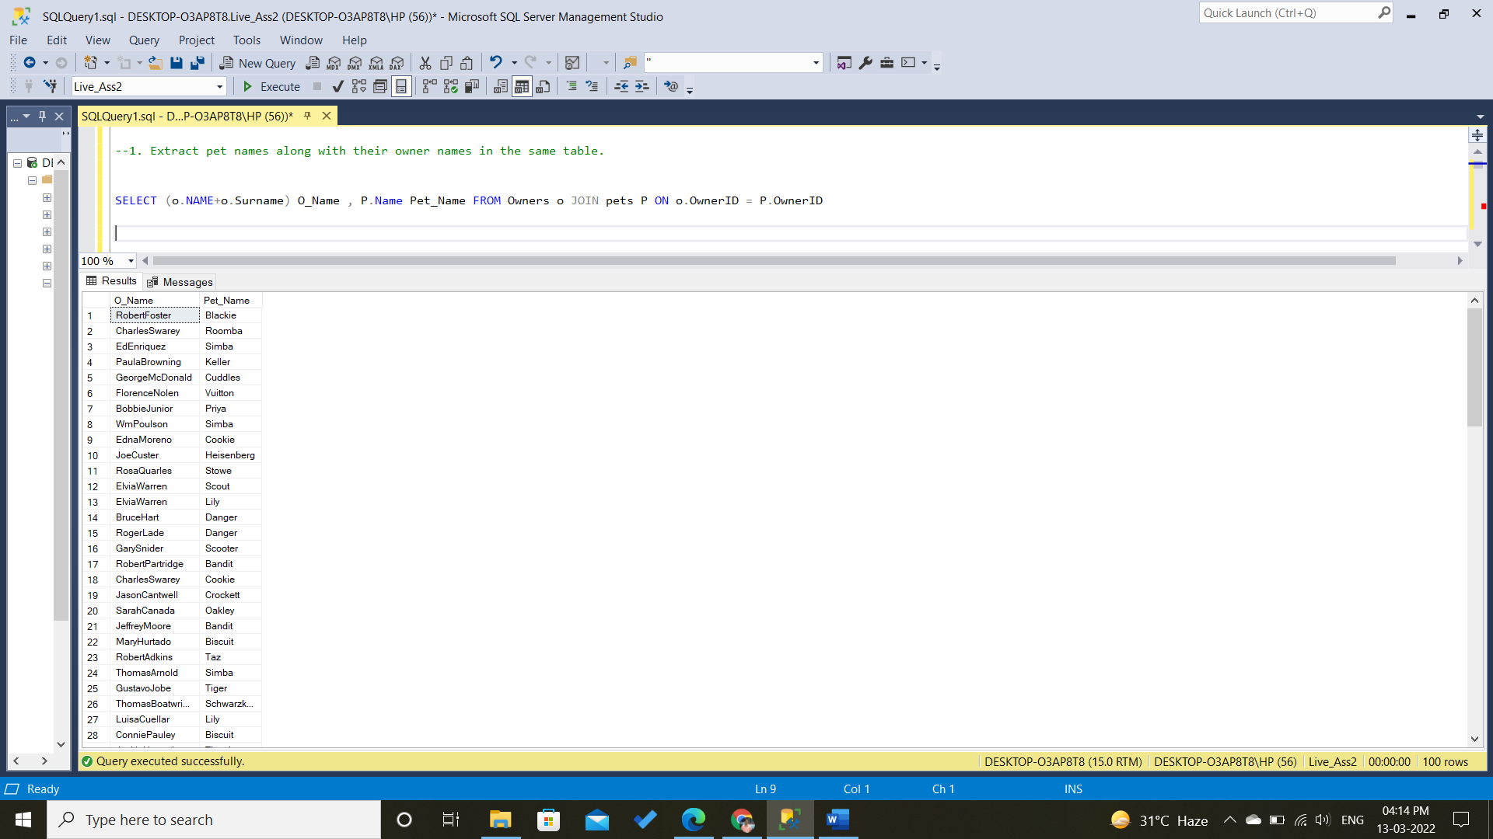

1. Extract information for those pets whose owners live in either “Grand Rapids” or “Southfield”.

Ans.

SELECT P.* FROM Owners o JOIN pets P ON o.OwnerID = P.OwnerID WHERE o.City IN ( 'Grand Rapids' , 'Southfield')

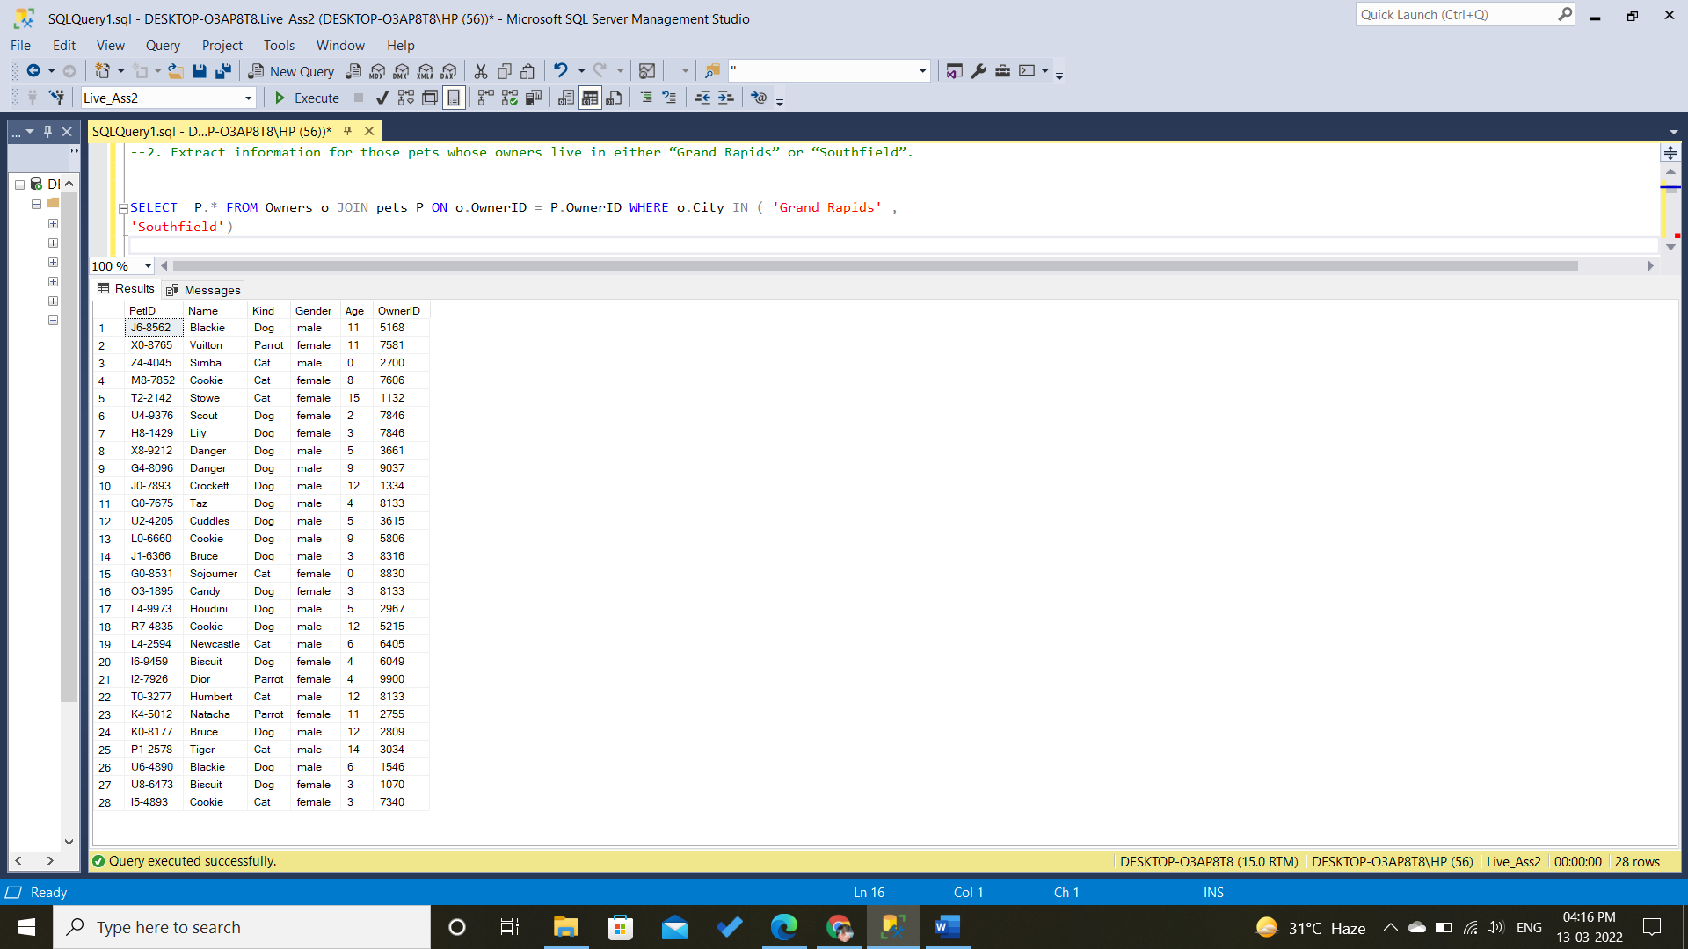

1. Extract information about the pets along with a description of the procedure performed on them.

Ans.

SELECT P.* ,PRD.Description FROM pets P join ProceduresHistory PRH ON P.PetID = PRH.PetID JOIN ProceduresDetails PRD ON PRD.ProcedureSubCode =PRH.ProcedureSubCode

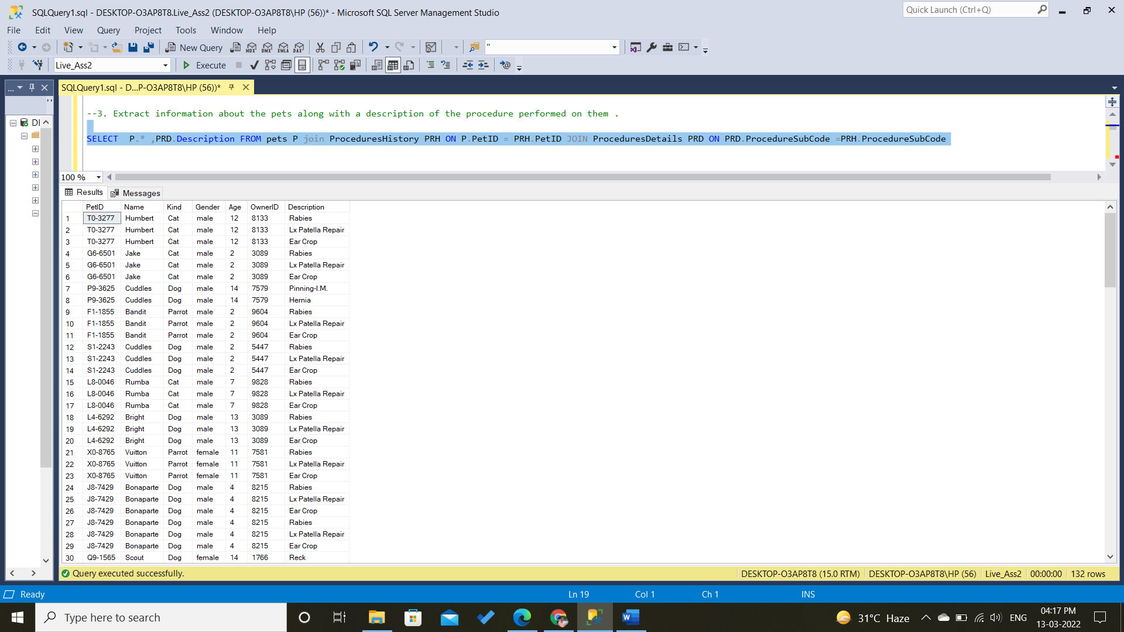

1. Same as 3 but only keep those pet ids which are present in pets.csv.
2. Find the sum of the price incurred on each pet’s procedure but only consider those pets whose name starts with ‘C’.

Ans.

SELECT P.NAME,P.PetID ,SUM(PRD.Price) PRICE_Inc

FROM pets P join ProceduresHistory PRH ON P.PetID = PRH.PetID JOIN ProceduresDetails PRD ON PRD.ProcedureSubCode =PRH.ProcedureSubCode

WHERE p.NAME LIKE 'C%'

group By p.petID , P.NAME

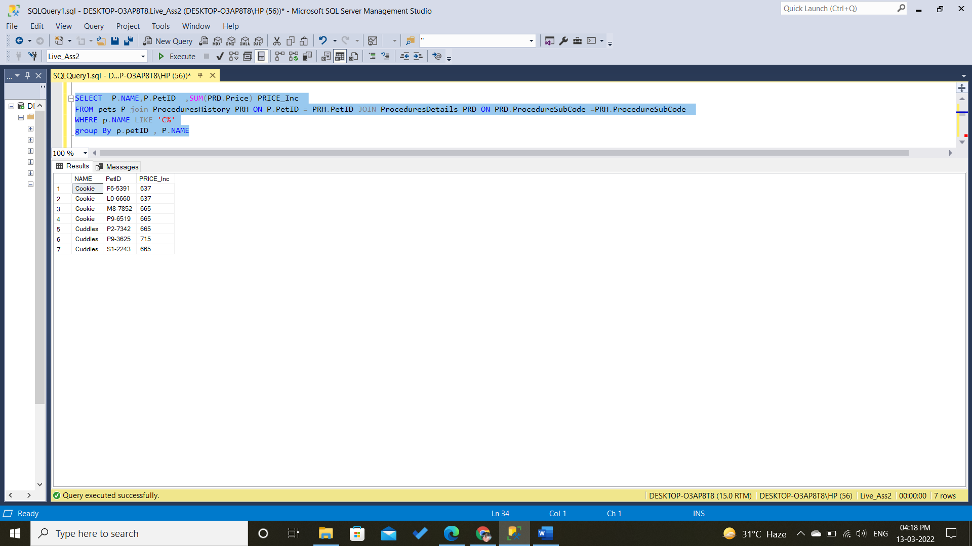

1. Find the owner names who own more than 1 pet, if there are any.

Ans.

SELECT (o.NAME+o.Surname) O_Name , o.OwnerID, Count(P.PetID) No_Pet FROM Owners o JOIN pets P ON o.OwnerID = P.OwnerID

Group BY o.OwnerID ,(o.NAME+o.Surname) Having Count(P.PetID) >1

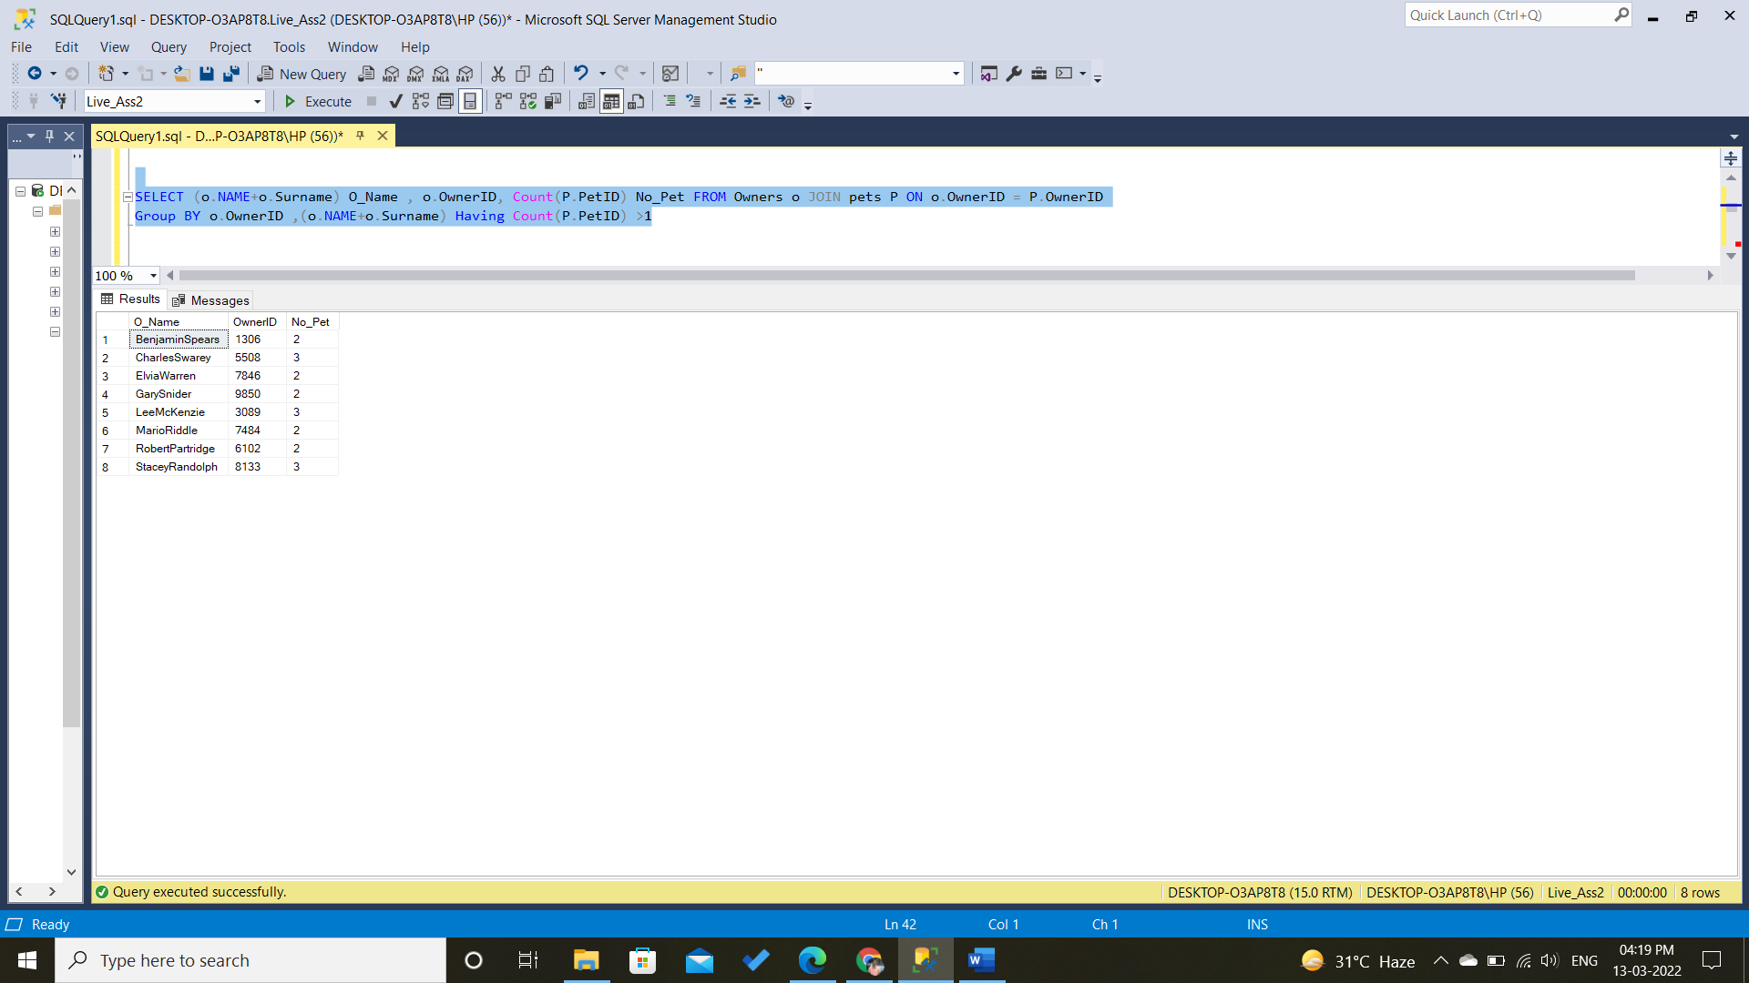

1. Find the count of procedures performed on each pet who are Dogs.

Ans.

SELECT Count(PRH.ProcedureType) No_proce , P.PetID , P.Kind FROM pets P join ProceduresHistory PRH ON P.PetID = PRH.PetID JOIN ProceduresDetails PRD ON PRD.ProcedureSubCode =PRH.ProcedureSubCode Where P.Kind = 'Dog'Group By P.petID, P.Kind

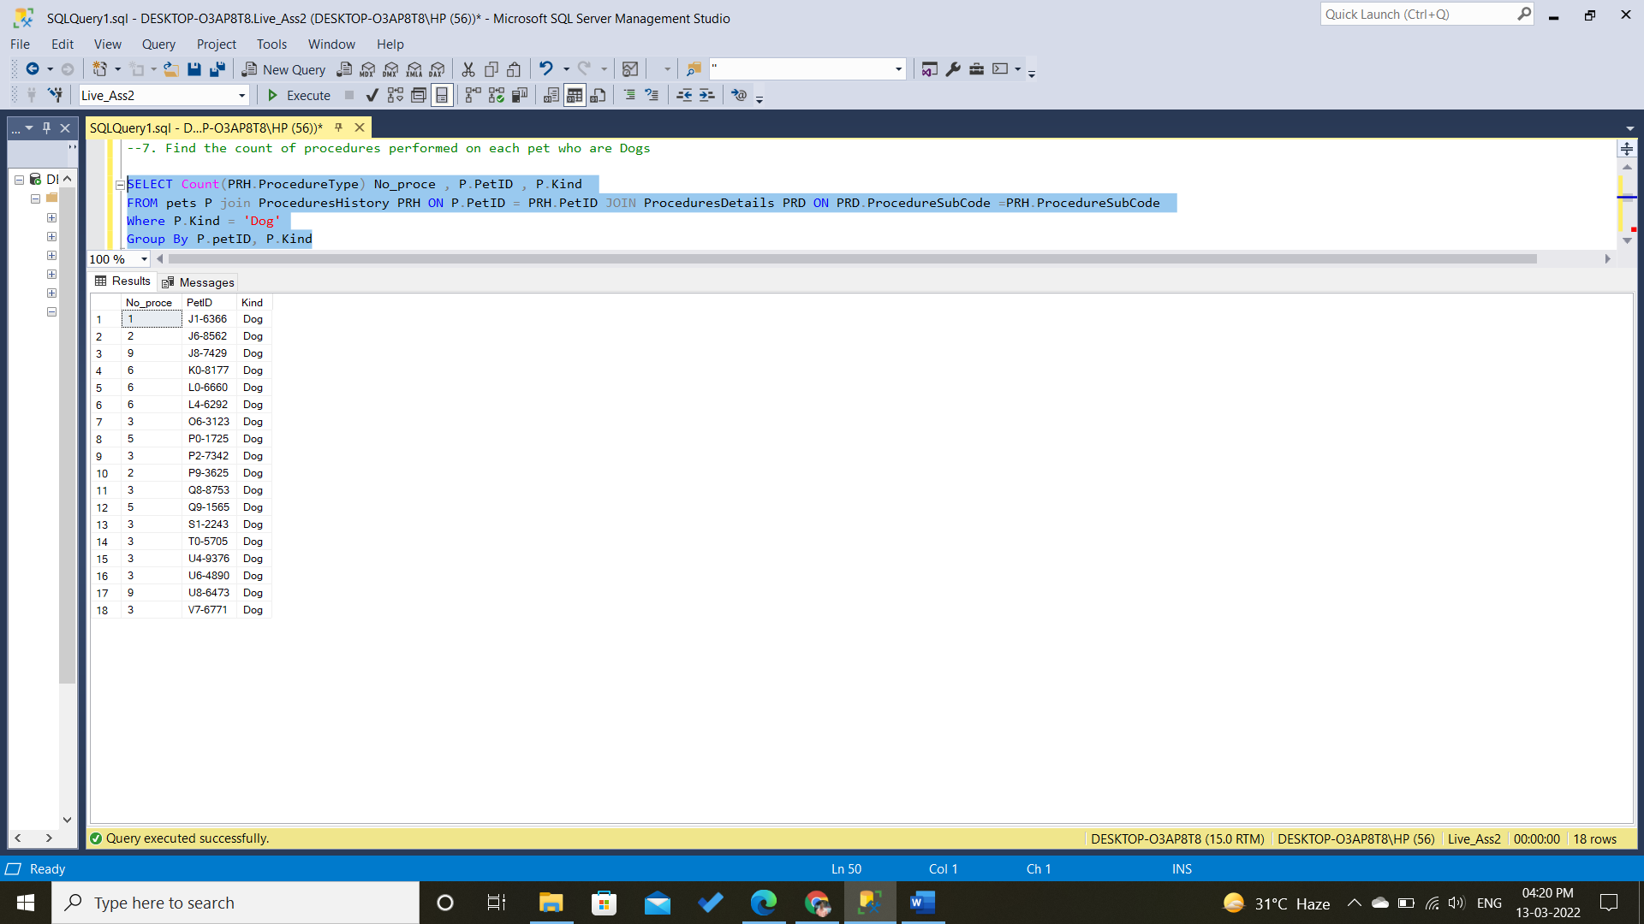

1. Find the average price incurred by each owner for their pet’s procedure.

Ans.

SELECT AVG(PRD.Price) AVG_Price , p.OwnerIDFROM pets P join ProceduresHistory PRH ON P.PetID = PRH.PetID JOIN ProceduresDetails PRD ON PRD.ProcedureSubCode =PRH.ProcedureSubCode GROUP BY p.OwnerID

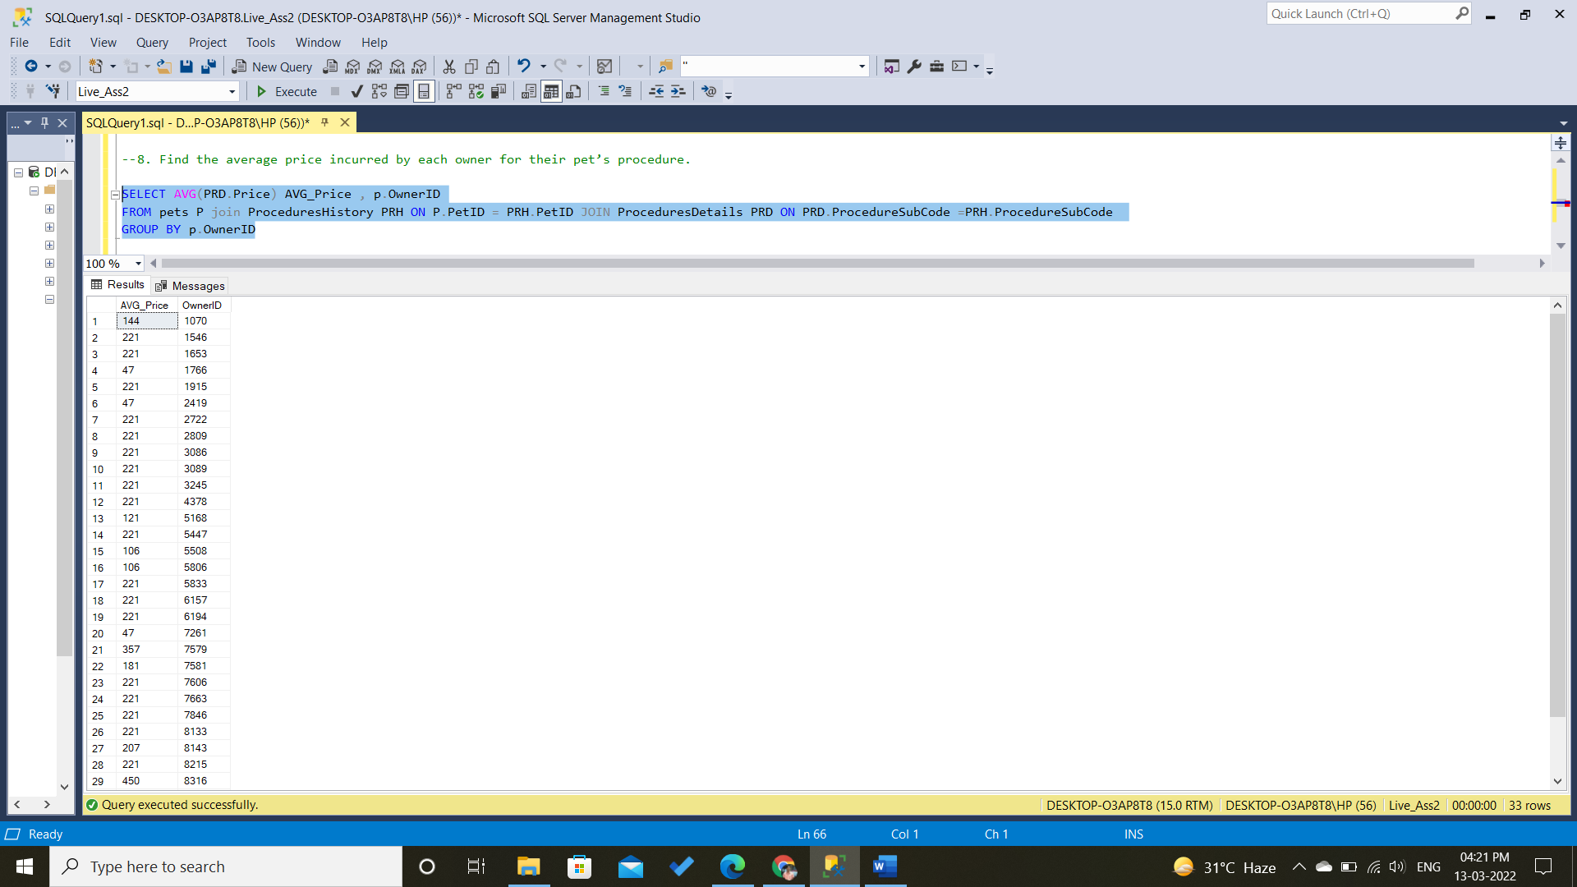

1. Find the cumulative sum of total procedures performed for each pet at a monthly level. (Use Self join and partition by both) .

Ans.

SELECT Month(DATE) Months, PetID,ProcedureType , COUNT(ProcedureType) Over (Partition By petID Order by Month(Date)) Cumm_Sum

From ProceduresHistory

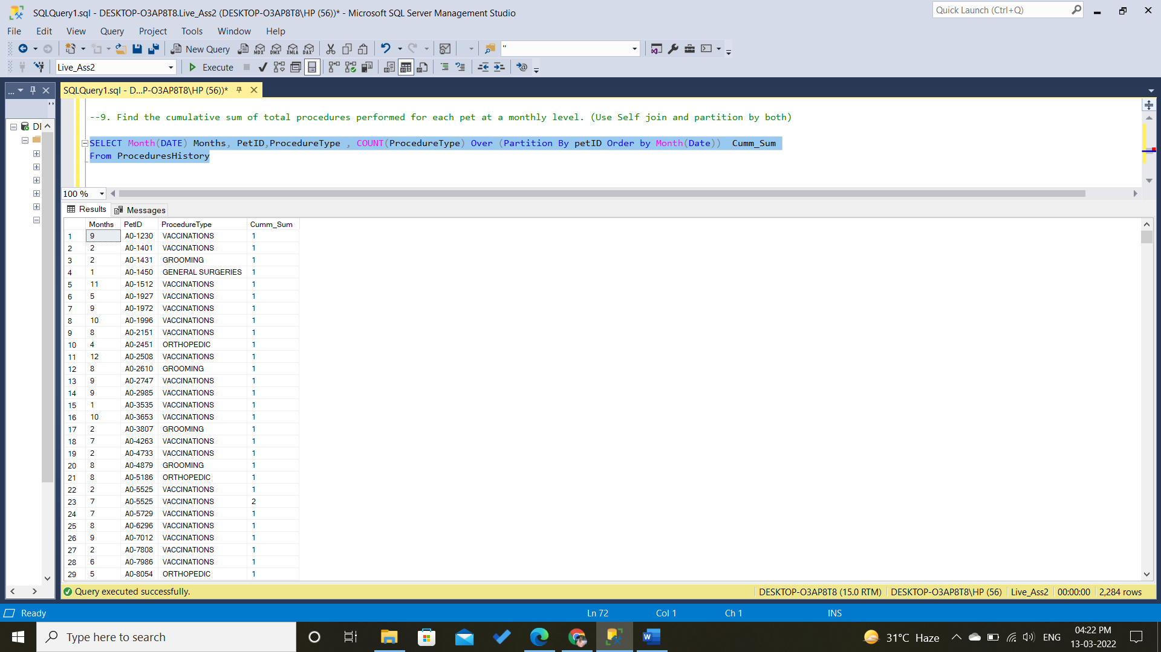

1. Extract information for those pets who have undergone procedure type “Vaccinations” with subcode 3, 4 and 5 or undergone procedure type “General Surgeries” with subcode 8,10,13,15,16. (Try both subquery and join).

ANS.

SELECT P.* FROM pets P join ProceduresHistory PRH ON P.PetID = PRH.PetID

WHERE (PRH.ProcedureType ='Vaccinations' And PRH.ProcedureSubCode IN(3,4,5)) OR (PRH.ProcedureType ='General Surgeries' And PRH.ProcedureSubCode IN(8,10,13,15,16))

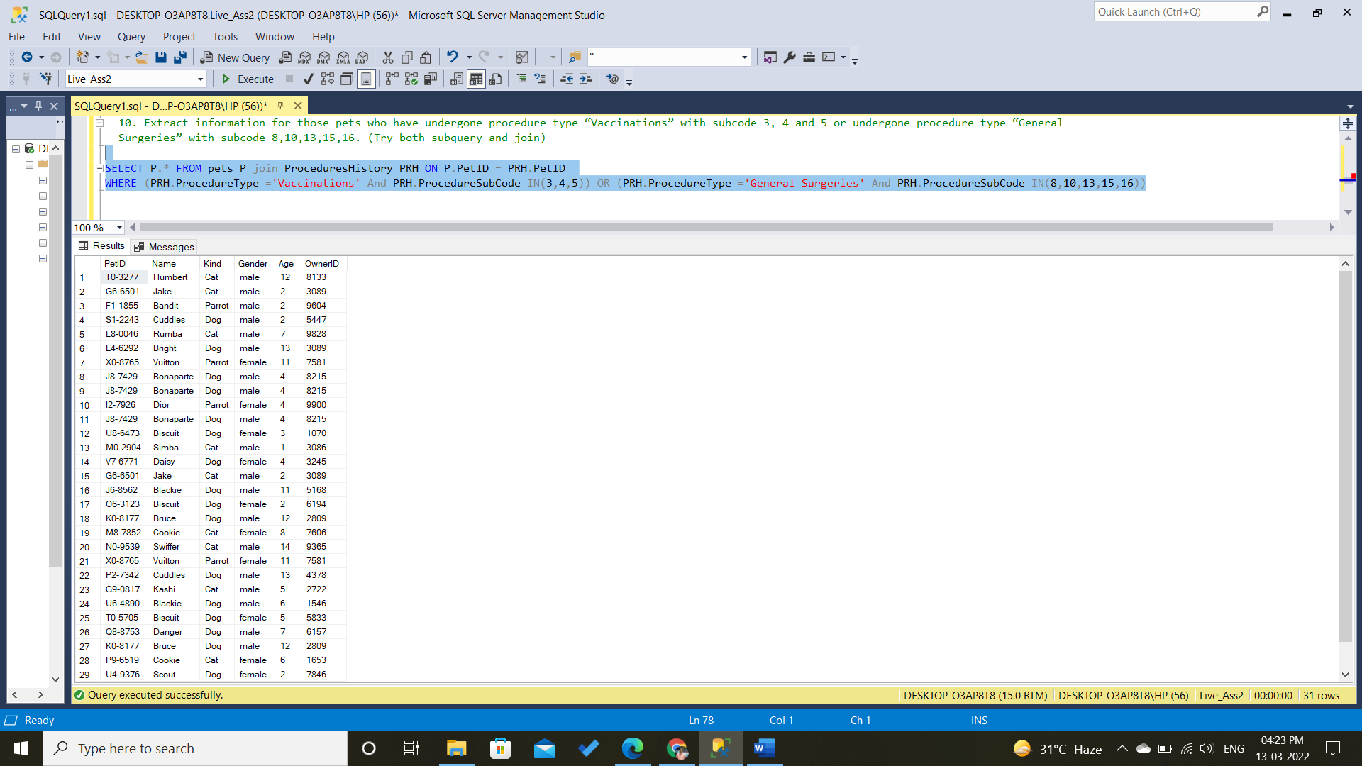

1. Find the top 5 pets in terms of fees paid for all the procedures performed.

Ans.

SELECT Top 5 P.NAME, P.PetID ,SUM(PRD.Price) PRICE_Inc

FROM pets P join ProceduresHistory PRH ON P.PetID = PRH.PetID JOIN ProceduresDetails PRD ON PRD.ProcedureSubCode =PRH.ProcedureSubCode

group By p.petID , P.NAME

ORDER BY SUM(PRD.Price) DESC

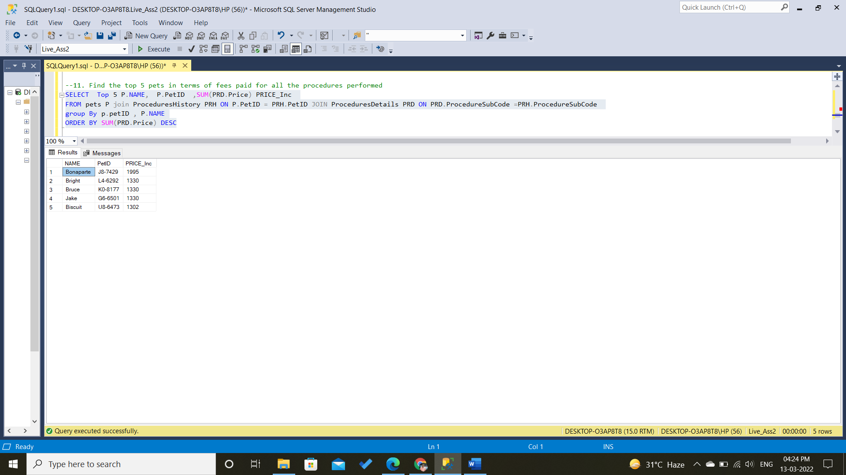

1. Find 4 owners who paid the least fees for procedures performed on all their pets.

Ans.

SELECT TOP 4 O.OwnerID ,SUM(PRD.Price) PRICE_Inc

FROM pets P join ProceduresHistory PRH ON P.PetID = PRH.PetID JOIN ProceduresDetails PRD ON PRD.ProcedureSubCode =PRH.ProcedureSubCode JOIN owners O ON o.OwnerID =p.OwnerID

group By O.OwnerID

ORDER BY SUM(PRD.Price)

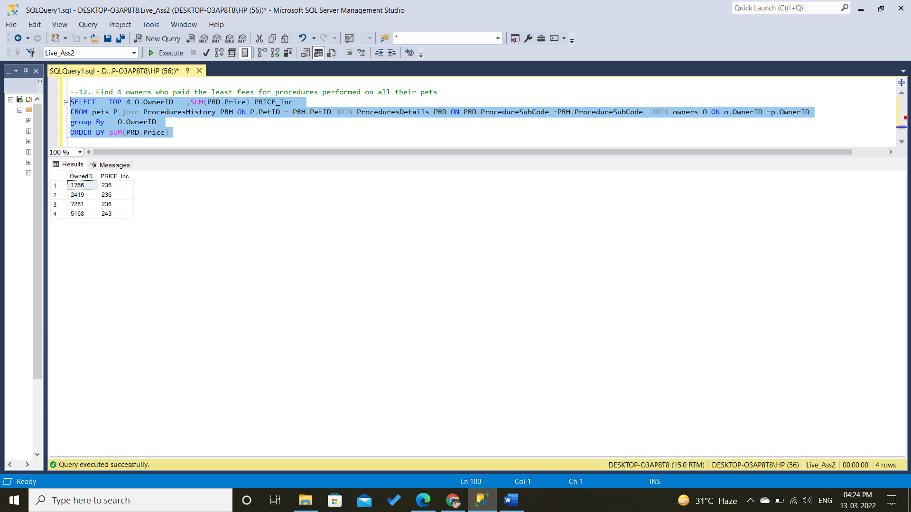

1. Find first and last date of procedure performed on each of the pets. The output should have columns (Pet Name, First Procedure Date, Last Procedure Date).

Ans.

select a.PetID, min(a.Date) as first_transaction_date,

max(b.Date) as last_transaction_date

from ProceduresHistory as a inner join ProceduresHistory as b

on a.PetID = b.PetID

group by a.PetID;

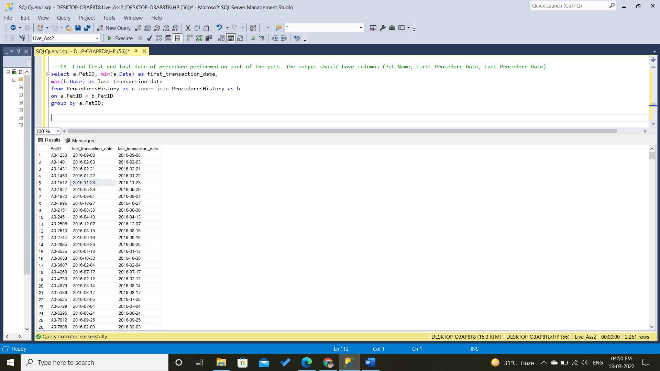

1. Find all the owners whose pet’s name does not begin from letters d to s.

Ans.

SELECT OwnerID , PetID ,name FROM pets Where LEFT(Name , 1) IN ('a','b','c', 't','u','v','w','x', 'y','z')

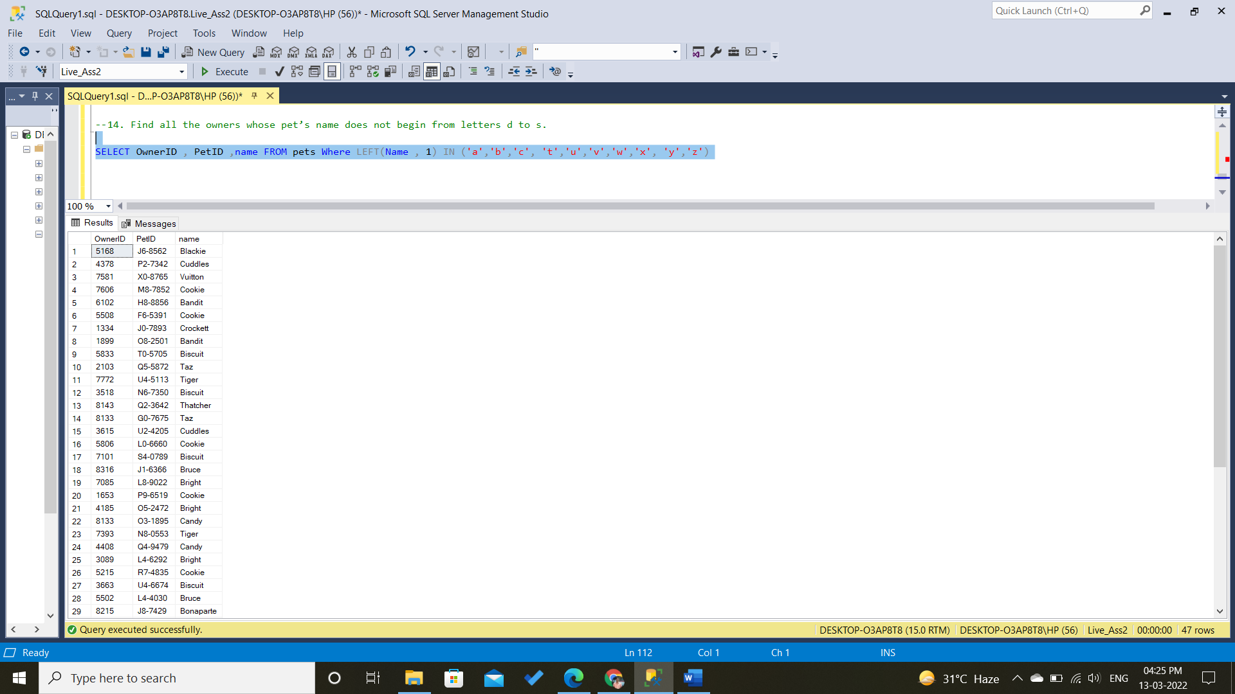

1. Find 4 day rolling average price incurred by each pet Id.

Ans.

SELECT PRH.PetID ,Prh.Date, AVG(PRD.Price) OVER( Partition BY Prh.PetId ORDER BY PRH.DATE ROWS BETWEEN 3 PRECEDING AND CURRENT ROW) roll_avg

FROM ProceduresHistory PRH JOIN ProceduresDetails PRD ON PRD.ProcedureSubCode =PRH.ProcedureSubCode

